

October 13, 2009

Dear Bruce,

The Committee on Curriculum and Instruction’s subcommittee for Arts and Humanities met on October 6th and discussed the Economics 500 course and unanimously approved it. Thank you for making all of the suggested changes from the committee.

We are removing the CAPs under “Argument Papers” and forwarding it to the Department of History for concurrence. Since you all have a long-standing history in offering courses in the historical studies category, and the course is well thought through and formed, we should hear from history quickly. After, they respond to us (they have a three week window) then we will forward it on to OAA and the Registrar’s office.

Thank you for your commitment to Undergraduate education at OSU,

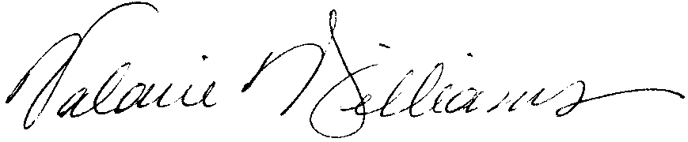
Valarie Williams
Chair, CCI Subcommittee B Arts and Humanities
Professor of Dance
Associate Dean, Arts and Humanities

